Lesson Overview:

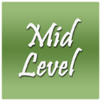
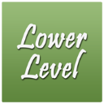

For ALL Students:

Related Common Core State Standards:

Common Core State Standards
Authors: National Governors Association Center for Best Practices, Council of Chief State School Officers
Title: Common Core State Standards (insert specific content area if you are using only one)
Publisher: National Governors Association Center for Best Practices, Council of Chief State School Officers, Washington D.C. - Copyright Date: 2010

DesCartes Statements:
RIT Above 230: | Students:
RIT 221-230 | Students:
RIT 211-220: | Students:
RIT 201-210: | Students:
RIT 191-200 | Students:
RIT 181-190 | Students:
RIT 171-180 | Students:
RIT 171-180 | Students:
RIT Below 171 | Students:

  Higher-Level Lesson & Activity: |  |  | Resources:
 |  |   
 |  |  | Means of Assessment:
  Mid-Level Lesson & Activity: |  |  | Resources:
 |  |  | Means of Assessment:
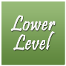 |  | Resources:
 |  | Means of Assessment:

